Jai Ho Sales

# Project Details

We have created a NoSQL database for our car rental service which consists of six collections further connected to a front end (web pages).

# GitHub URL

<https://github.com/naharprabh786/Final-Project-CSD4403_1>

# Team Members:

|  |  |
| --- | --- |
| Student ID | Student Name |
| 755080 | Prabhdeep Prithvi |
| 749083 | Guruvindar Singh |
| 748927 | Bharat Sandhu |

# NoSQL Database Information

Database Name:

|  |  |  |
| --- | --- | --- |
| Collection Name | Collection Details and #of Documents available | Team Member(s) worked on it |
| Branch | BranchID, Address | Prabhdeep Prithvi |
| Car Model | CarID, Manufacturer, Year Make | Prabhdeep Prithvi |
| Customer | CustomerID, Address, First Name, Last Name | Bharat Sandhu |
| Employee | EmployeeID, Hours Worked, Commission, First Name, Last Name | Bharat Sandhu |
| Orders | OrderID, Address, Delivery Date | Guruvindar Singh |
| Sales | SaleID, CarID, CustomerID | Guruvindar Singh |

Database backup file: Attach your database backup file here so that it can be restored and used.

# NodeJS Service Information

|  |  |  |
| --- | --- | --- |
| Service Path | Details | Team Member(s) worked on it |
| Data from mongo database | Service reads data from the database | Prabhdeep Prithvi |
| App.get | Service gets the specific data according to query | Bharat Sandhu |
| App.put | Service update current data in database | Guruvindar Singh |
| App.post | Service inserts new data in database | Prabhdeep Prithvi |
| App.delete | Service deletes particular data as per query | Guruvindar Singh |

Service Codes: Attach the NodeJS code package here.

# Application or Website details

Provide screen shot with details.

Attach the codes. 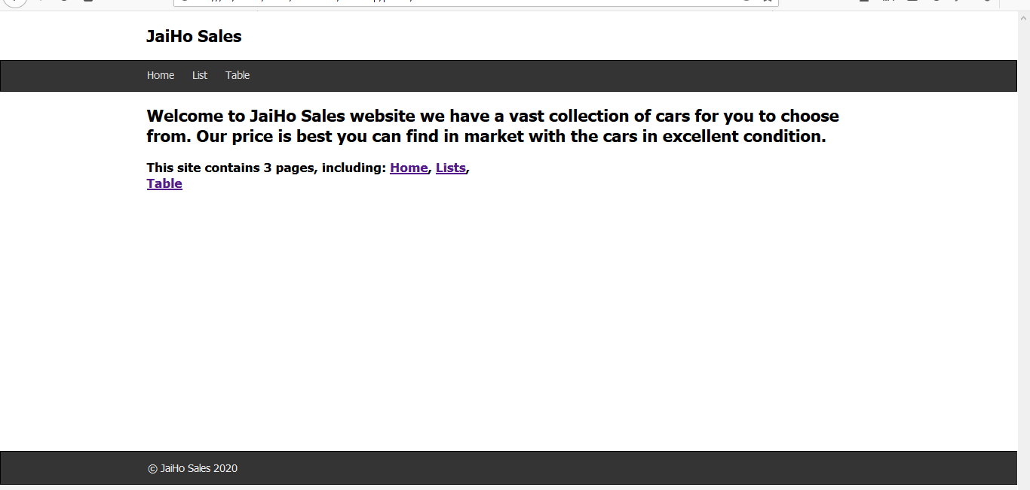

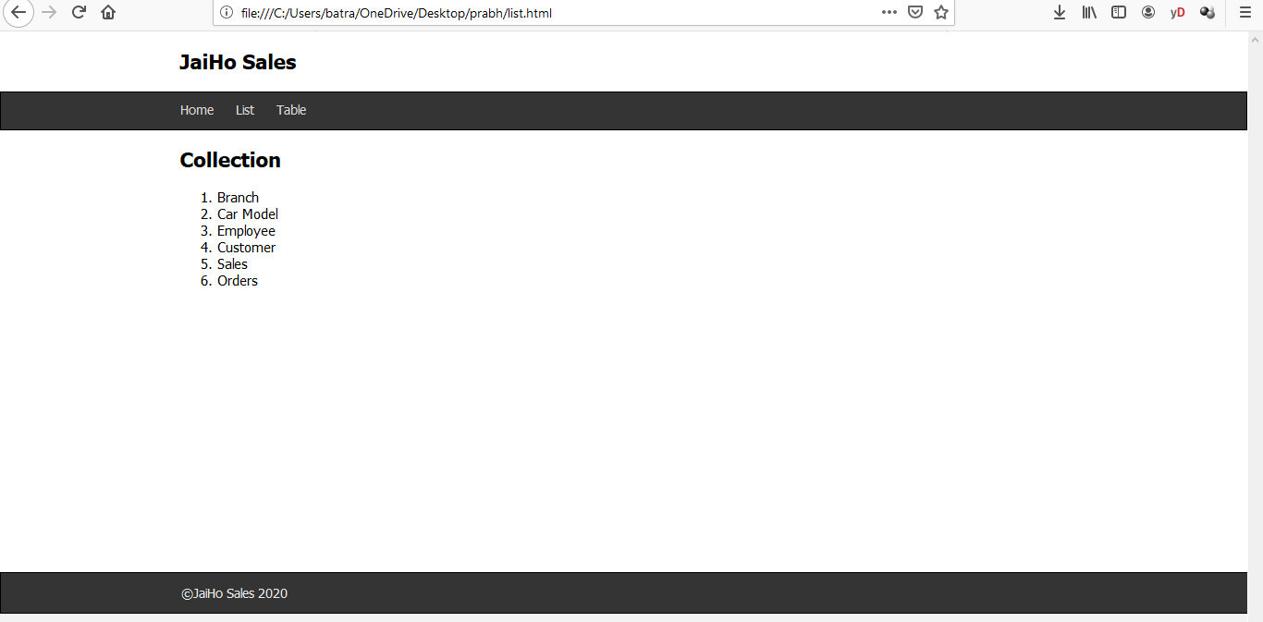

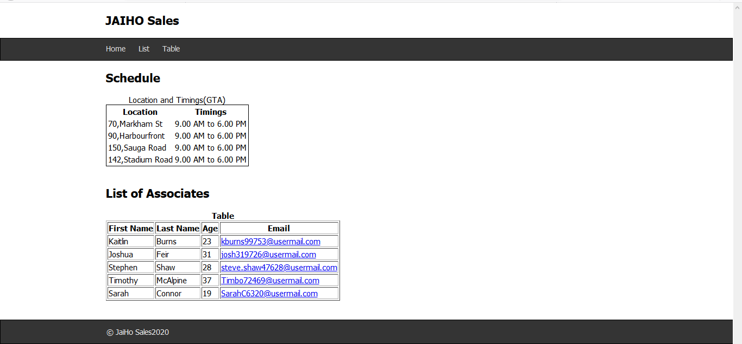

# How this application will be deployed into Cloud?

Three possible deployment choices for application code are there: infrastructure as a service (IaaS), platform as a service (PaaS), or software as a service (SaaS). We will have to select the right option among these services. For legacy or existing applications, we will choose a PaaS provider that supports both stateful and stateless applications.  
For our application, Paas (Platform as a service) would fit best.   
With the PaaS platform, everything is provided but the application code, users, and data besides provides features that are specifically meant for applications, including the ability to scale the application tier up based upon the user demand of the application. In most platforms, this happens with little-to-no interaction from the developer.

# Add Screen shots of your front end and services in Postman

Add as many screen shot as needed.

# Score Distribution

# Score Distribution

|  |  |  |  |  |  |
| --- | --- | --- | --- | --- | --- |
| Module | Total Marks | Student 1 | Student 2 | Student 3 | Student 4 |
| NoSQL Database | 8 |  |  |  |  |
| NodeJS Service | 8 |  |  |  |  |
| Application | 8 |  |  |  |  |
| Cloud Deployment Details | 8 |  |  |  |  |
| GitHub | 4 |  |  |  |  |
| Participation | 4 |  |  |  |  |
| Total | 40 |  |  |  |  |